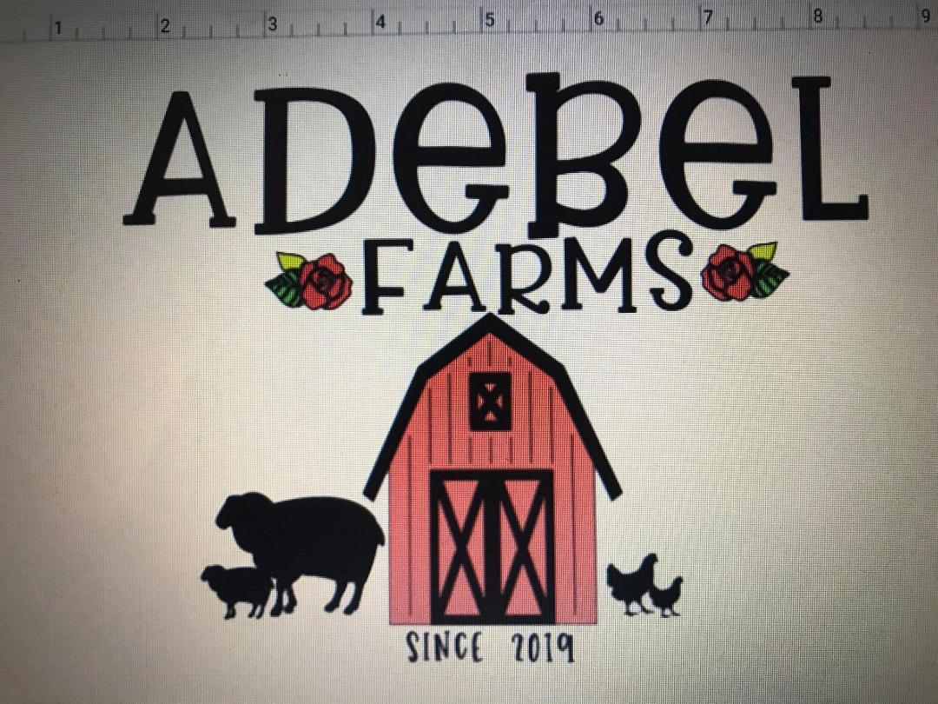
Puppy Contract

Name: __________ Breed: Great Dane Color: _____ DOB:___March 18th 2020____
Purchase Price: $_______ Type of Registration:
Sire: ___Diesel’s Chronicles of Riddick Von Kaiser_____________________________________
Dam: ____McKay’s Lennon _____________________________________________

This contract is solely between named seller/breeder and named buyer
Buyer:____________________________
Seller: Veronica McKay with Adebel Farms Animal Breeding

Payments must be made in full before receiving/shipping the puppy. All shipping costs are the responsibility of the buyer.
Option of pick up at my home is always available.
A non-fefundable deposit of $ 500.00 must be paid in order for the breeder to reserve or hold a specific puppy. No refunds will be made of deposits/payments unless the bite is not correct at 8 weeks old or the puppy is in horrible condition and is not fit for sale.

1) A licensed Veterinarian must check this puppy within 72 hours from the time of pick up. Copy of the report must be sent to the breeder.

2) Seller guarantees this puppy to be in good health at the time of pick up with all vaccinations and de-worming up to date.

3) Health issues that can be cured by medication or minor surgery are not covered by the breeder.

4) All puppies will be up to date with age appropriate vaccinations but puppies are still vulnerable to viral and/or bacterial infections including any puppy diseases. It is the buyer’s responsibility to finish the Puppy Booster vaccines, they should be given every 3-4 weeks, until the puppy is 16 weeks of age. Every Adebel Farms puppy should be given vaccines by a licensed Veterinarian only, NEVER given vaccines from a Feed Store. If feed store vaccinations are given, you are forfeiting your Health Guarantee.

5) Breeder provides a safe & healthy environment for all puppies while in my care and are not exposed to communicable diseases.
Breeder does not guarantee against any puppy diseases that are contracted after receiving the puppy, since the breeder cannot control what the puppy is exposed to when no longer in the care of the breeder. It is highly recommended that the puppy is not exposed or taken to new places until he/she has received all vaccinations. Breeder also does not guarantee against anything the puppy is exposed to during shipping.

6) Breeder is not responsible for any accidents after the buyer gains physical possession of the puppy, regardless of method of shipping and/or pick up. All responsibilities of the puppy are released at the time your puppy is picked up or shipped. Breeder is also not responsible for nutrition related issues, OCD, HOD, knuckling or any growth issue due to poor nutrition/over nutrition/worms/poor care by the new owner/ lack of veterinary care ect.
Great Dane puppies need a quality diet that includes a kibble/food with the following formula:
Phosphorus/Calcium 1:1.2
Protein: 23-30% (NEVER higher than 30%)
Fat: 9%-14%
Grain Free: NEVER FEED GRAIN FREE FOOD!
The 2 foods that we recommend:
- Iams Large Breed Puppy or Purina One Large breed until 24 months of age, then switch to Iams/Purnia One Large Breed Adult.
- Royal Canin GIANT Breed JUNIOR until 24 months of age, then switch to Royal Canin GIANT Breed Adult.
If the seller does not feed within the above formula, the seller forfeits the puppy’s Health Guarantee. There is no “one size fits all” dog food. Giant Breeds need Giant food formulas for proper growth and development. No supplements, no added calcium or any other additives that would push a Great Dane puppy into a faster growth phase are acceptable. The only supplement that may be given is Vitamin C for certain occasions. All puppies must be kept in a lean body condition. Keep treats to a minimum.

7) No strenuous exercise until the dog is 24 months of age. This allows for proper setting of the growth plates. Grain Free Foods should NEVER be fed to an Adebel Farms puppy.

8) No puppy purchased from Adebel Farms is ever to be abused, abandoned, neglected or improperly bred (see #8B below). Buyer agrees that if at some point they can no longer care for this puppy/dog it will be returned to Adebel Farms or go to an approved home
by Adebel Farms. Approval must be given in writing and home to be screened by Veronica McKay. No Adebel Farms puppy should be taken to a shelter for any reason.

8A.) ALL Puppy Buyers from Adebel Farms are REQUIRED to register their puppy with the AKC, this includes puppies sold with Limited Registration. Buyer agrees never to sell or place this puppy/dog into another home without it being spayed/neutered prior to rehoming in the new home. Unless you have written approval from the breeder. Exceptions are only given in writing with a signature, in the case of something in this agreement being changed. Puppy will come with a Microchip. Buyer agrees to keep Seller on the Microchip’s contact list along with Buyer’s up to date information for the duration of dog’s life

8B) Buyer agrees to adhere to the ethical breeding standards outlined by the Great Dane Club Of America. Buyer also agrees not to breed a bitch prior to the age of 2 years old. Buyer agrees to only breed to healthy Danes, correct conformation and correct color code applies. Meaning this puppy would only be bred to a Black Mantle, Harlequin, Merle, Black w/White or solid Black from Harlequin pedigrees.
This puppy is to never be mixed with a fawn, brindle, blue or black from blue bloodlines. Any breeding, accidental or not that goes against this agreement will be considered a violation and breach of this contract. Buyer must have dog’s following Preliminary Health Test completed and the results must be sent to Breeder, BEFORE breeding:
1. OFA/Penn-Hip
2. OFA Eye Screening
3. Cardiac Screening
4. Thyroid
Buyer agrees to keep breeder notified of any Dog Shows entered, results, win/points
earned, and provide photos when asked. Any photos supplied directly to the Breeder or on any of the Breeder’s Social Media can be used by breeder for advertising purposes.

9) Puppies placed as show/breeding or service dog potential with full AKC Registration are not guaranteed to be show quality or exhibit qualities of service dog potential. It is impossible to know show quality or how great a service dog one might be until the dog matures into an adult. Show quality is determined by not only the breeding/pedigree, but with proper grooming/nutrition/training ect. Show/breeding potential is just that; potential and buyer has the right to show or breed the dog. Also, a dog that exhibits service dog potential, is just that as well, potential and success will be determined on the dog’s maturity and willingness to work as a service dog. The puppy/dog does not have to be spayed or neutered to have the Full AKC Registration.

10) Puppies placed as “pets” on Spay/Neuter agreements with Limited AKC Registration must be spayed or neutered between 12 Months-24 Months of age. Once spaying/neutering occurs, you must notify Breeder in writing.

11) Conditional Health Guarantee:
A) Breeder supplies a 2-year conditional Health Guarantee at breeder discretion. Breeder only guarantee's hips to be free of mild or severe hip dysplasia that is not a result of an injury and hearts good and free of DCM for 2 years of age, as long as Grain Free Food has NEVER been fed to puppy/dog.
Grain free dog foods, food formulas that do not match above recommendations (see section #6) and vaccinations given by anyone other than a Licensed Veterinarian VOID this health guarantee.

If within the puppy/dog’s life the breeder questions the care, nutrition or medical care practices then any health guarantee is null and void.
If prior to the dogs 2nd birthday the dog is found to have DCM or mild/sever hip dysplasia to be found out via Penn Hip health testing only, then a replacement puppy with the same value will be provided upon spay of the original puppy. Proof of spay/neuter of the original
puppy is required, and proof sent to Veronica McKay.
Breeder refuses to replace a puppy in a home that turned out to be questionable in any way. Breeder does not guarantee against puppy diseases in any way. Puppies are guarded against being exposed to puppy diseases while in the breeder’s care. Breeder has also provided
vaccination/deworming record to buyer. At any point within the first 2 years of the life of the puppy/dog he/she has a life threatening DCM or mild/sever hip dysplasia health issue that has been brought to the attention of the breeder along with satisfactory Veterinary records provided to breeder then the breeder has discretion as to if a replacement puppy will be offered at that time. Breeder does not refund any monies paid to the breeder for the purchase of the puppy and is not responsible for vet/medical care after the puppy is in the care of the buyer. Breeder does not guarantee against anything that is a result of injuries of any kind, side effects of medical care, lack of medical care, nutrition issues, HOD, OCD, Pano, Coccidia, Demodex, or any other condition that is not listed with in the health guarantee section.

12) There is no oral representation or warranties not contained herein. This contract of sale contains the entire agreement between the two parties. This contract is not transferable in any way. A breech in any part of this contract will make health guarantee null and void.

13) Any legal issues to be resolved will be in Collin County, Texas. Any violations to this contract is subject to a $5,000 fine.

Buyer of this puppy/dog agrees to any and all terms of this agreement and relinquish any rights that might otherwise be entitled to.
Buyer acknowledges that any deposits and monies paid for this puppy is non-refundable.

Buyer Signature & Date

____________________________________________________________________
_____________

Breeder Signature & Date
Veronica McKay___________

